YEAR 12 HISTORY

SEMESTER TWO 2000

Time Allowed For This Paper:

Reading time before commencing this work: 10 minutes
Working time for paper: 3 hours

Instructions to Candidates:

This paper consists of TWO sections as follows:

Part A Document Analysis: Answer ALL questions in response to the documents included. You must answer both sets of documents.

PART A Worth 50 Marks

Part B Essay: Choose TWO of the SIX essay topics. You must answer 1 from each

section.

PART B Worth 50 Marks

REMEMBER TO HAND IN YOUR EXAM BOOKLET WITH YOUR ANSWER BOOKLET
AT THE END OF THE EXAM.
HISTORY DOCUMENT BOOKLET

Document Set 1: International Relations 1945 – 1990: Europe

Source 1

(Extract from John Gaddi, The Long Peace, published in the later 190’s)

The relationship between the Soviet Union and the United States has not been free from ideological rivalries; it could be argued, in fact, that these are among the most ideological nations on the face of the earth. Certainly their respective ideologies could hardly have been more directly opposed, given the self-proclaimed intention of one to overthrow the other. And yet, since their emergence as super powers, both nations have demonstrated an impressive capacity to [place their ideological interests aside in favour of] a common goal of preserving international order… That such ideological impulses could be restrained to the extent that they have been during the past four decades testifies to the stake both Washington and Moscow have developed in preserving the existing international system; the moderation of ideologies must be considered . . . along with nuclear deterrence . . . as a major self-regulating mechanism of postwar politics.

The Cold War, with all of its rivalries, anxieties, and unquestionable dangers, has produced the longest period of stability in relations among the great powers that the world has known in this century; it now compares favourably was well with some of the longest periods of great power stability in all of modern history…

Who is to say, therefore, how the historians a century from now . . . will look back on us. Is it not at least plausible that they will see our era, not as ‘the Cold War’ at all, but rather . . . as a rare and fondly remembered “Long Peace”?
Document Set 1: International Relations 1945 – 1990 : Europe (cont.)

Source 2

THE BALANCE OF TERROR

(Relative nuclear capacity of super powers from figures supplied but not verified in 1985.)

NUCLEAR DELIVERY VEHICLES | USA | USSR
Strategic long-range bombers capable of delivering nuclear weapons. | 330 | 170
Intercontinental ballistic missiles (ICBMs) with multi warheads (up to 10 per missile) – range of 10 000 kilometres. | 1260 | 1530
Submarine-launched ballistic missiles (SLBMs) range of 2000-4000 kilometres | 750 | 1095
Intermediate range mobile ballistic missiles (IRBMs) launched from aeroplane, railway or road truck, e.g. Cruise missiles (USA), SS-20 (USSR) – range of 4000 – 5000 kilometres (estimates only) | 460 | 400
Total number of warheads | 9870 | 9300
Total delivery capacity of these warheads in megatons | 3695 | 7120

These figures do not include the complex system of anti-missiles that each country possesses. These are classified as defensive rather than offensive weapons.

Nor do they include the numerous small short range anti-personnel anti-tank field atomic weapons that would be launched from a distance of 50-100 kms at the enemy in actual land warfare.

END OF DOCUMENT SET 1

DOCUMENT SET 2 : Australia 1945 – 1990

SOURCE 1

(Extract from Studies of Society and Environment by Robert Engwerda and Richard Cotter, published in 1997)

THE ROAD TO EQUAL PAY

1949
The female basic wage was set at 75 per cent of the male basic wage. In most occupations prior to World War II, women received just over half (54 per cent) of the wage men received for doing exactly the same work.

1951
The United Nations recommended that there should be equal pay for equal work regardless of sex, race or religion. In Australia, governments, employers and male-dominated unions did not support this recommendation for a long time. By 1962 unions began to accept the idea of equal pay for equal work.

1969
Meat workers took the equal pay case to the Australian Industrial Relations Commission. The commission decided that women should receive equal pay if it were proven that they were doing exactly the same job in the same occupation. Women protested against the decision because it disadvantaged women who worked in female-dominated industries such as childcare and nursing.

1972
The Industrial Relations Commission finally accepted equal pay for equal value. This helped to extend equal pay to industries in which most workers were women.

SOURCE 2

(Extract from the 1977 report of the Royal Commission on Human Relationships, which recommended a rethinking of the value of work done by women in the home)

We feel a lot of the problems of mothers are reflected in the fact that motherhood is not recognised as an occupation. Mothers are still classified as dependants of their husbands, and this introduces a host of difficulties in so far as being able to identify oneself as an independent person.

Childbearing seems to be regarded in the nature of a hobby. It is something you just cannot claim any real financial credit for.

A financial partnership would overcome many problems. The mother would then have status. She would be recognised in her rightful functions as her husband’s partner. This would also put the mother on a more equitable footing with the woman who prefers to have her children raised by somebody else and to retain her employment benefits.
DOCUMENT SET 2 : Australia 1945 – 1990 (cont.)

SOURCE 3

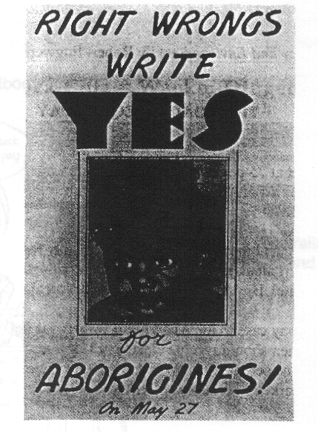
A poster issued during the 1967 Australian national constitutional referendum campaign, in which electors were asked to vote for or against a proposal to include Aboriginal people in the census and to give the Commonwealth Parliament the power to make special laws for the Aboriginal people.
(Result: Yes 5,183,113 No 527,007)

Source 4

A comparison of total and Aboriginal and Torres Strait Islander populations
Characteristic | Total Population | Aborigines and Torres  Strait Islanders
Expectation of life at birth (1981) (years) | 75.0 | 52.0
Infant mortality rate (1981) (per 1000) | 9.6 | 25.4
Total fertility rate | 1.9 | 2.6
% aged less than 15 years | 23.3 | 39.8
% aged ore than 65 years | 10.6 | 2.7
% in urban areas | 85.4 | 66.5
Per capita income (A$ annual) | 9600 | 6210
% with individual incomes <15 000 p.a. (1986) | 47.0 | 75.0
Unemployment rate (1986) | 9.2 | 35.3
% employed as (1986):  Professionals, managers, administrators  Labourers and related workers | 23.5  14.3 | 8.4  32.3
% with degree, diploma, or higher (1986) | 8.6 | 1.0
% of persons living in rented housing (1986) | 22.9 | 72.9
% of persons in prison, corrective and detention institutions | 0.1 | 0.8

Table in a 1987 Australian Government Publishing Service publication
DOCUMENT SET 2 : Australia 1945 – 1990 (cont.)

Source 5

(Cartoon from a secondary textbook published in 1992)

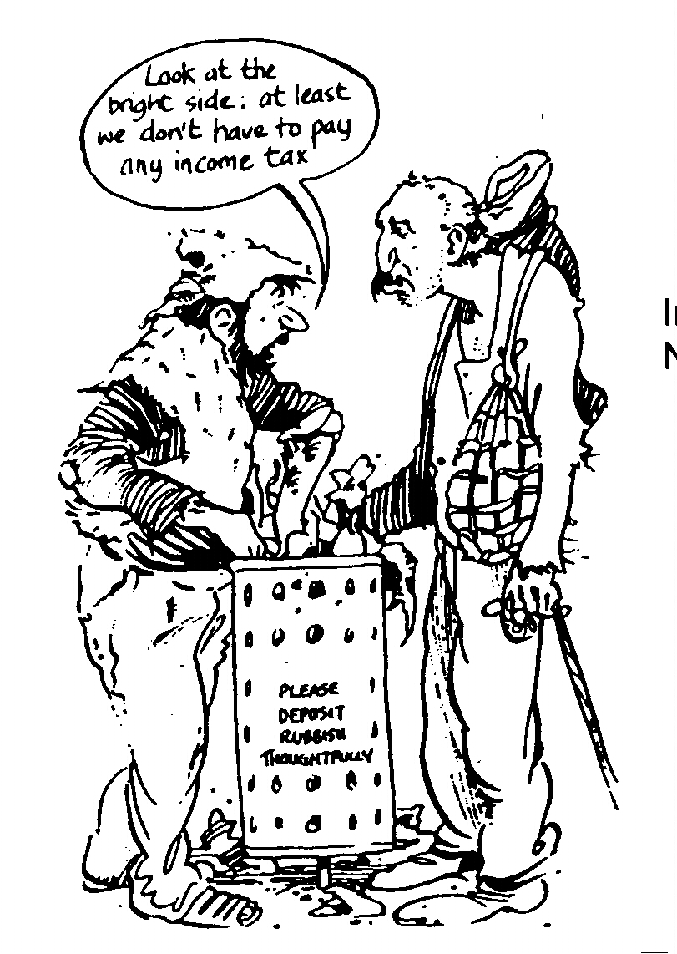

In the 1980’s Australia was becoming at nation of
Nation of ‘haves’ and ‘have nots’.

Source 6

(From a newspaper article published in the Age, Melbourne, in 1987)

‘Australia not so fair, says report’

The rich in Australia are getting richer at the expense of the poor and the middle classes, making the so-called lucky country one of the least egalitarian of industrialised nations, according to an analysis by the University of New South Wales.

The director of the university’s Social Welfare Research Centre, Dr Peter Saunders, said that when income distribution in eight countries was compared Australia was found to be only slightly more egalitarian than Germany and the United States, which were at the bottom of the table. Even Britain was ahead of Australia in terms of a “fair go”, the centre’s report said. New Zealand was near the top.

Dr Saunders said the top 20 per cent of Australian families received 43.7 per cent of the gross income of all families, and the bottom 20 percent received 4.6 per cent. In Germany the top 20 per cent received 46.9 percent, and the bottom 4.4 per cent; in the US, the richest 20 per cent took 44.5 per cent, and the bottom, only 3.8 per cent. Sweden had the most equal distribution of income, followed by Norway…..

The analysis showed the income share of “middle” families in Australia was well below that in most other countries.

Dr Saunders said the analysis was part of a large international research project… Most of the data was from the early 1980’s. He expected the results to surprise some people, because there was a general view, partly stemming from research in the 1970’s that income distribution in Australia was fairly equal.

“I think the results…hopefully can destroy the myth that Australia can be complacent about having an equal distribution of income, because, relative to a lot of other countries, it hasn’t.”
DOCUMENT SET 2 : Australia 1945 – 1990 (cont.)

Source 7

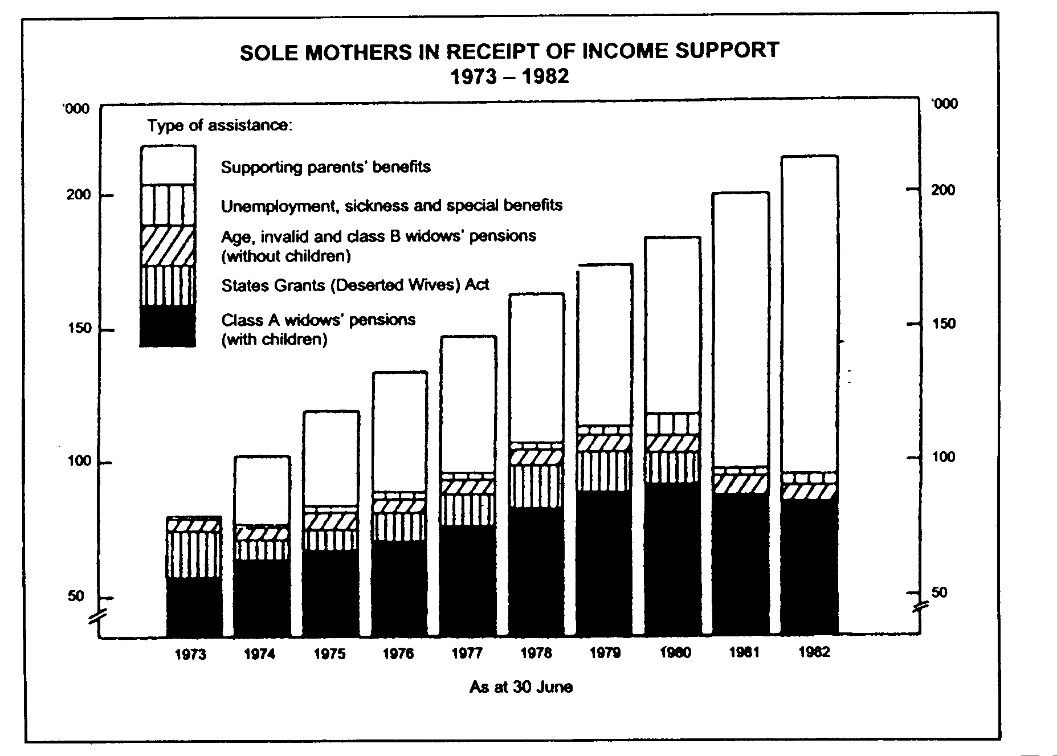
From the Annual Report of the Australian Department of Social Security, 1982.

Source 8

(Extract from a newspaper article published in the Age, Melbourne, in 1988)

The Australian community was stereotyping and disregarding the needs of vulnerable groups, the Minister for Social Security said last night…

Mr Howe, who is also a Uniting church minister, spoke about the increasing number of new poor, particularly sole parents and the long-term unemployed, brought about by structural changes in the economy.

Instead of assisting these people, the community had stereotyped and ignored them, he said.

The stereotype of a sole parents, for instance, as a teenage unmarried mother, was entirely misplaced. Evidence of this was the fact that this group made up only four percent of the total, he said.

Mr Howe made a scathing attack on the “lethal attitudes of talkback radio…my experiences of which have shown me that sole parents are hated by more Australians than anyone else…”

The community should simply accept that there was a need for help and respond accordingly, Mr Howe said.
DOCUMENT SET 2 : Australia 1945 – 1990 (cont.)

Source 9
(Extract from an analysis of Australian census data published in the 1980’s)

Changes in the Family Structure
Is the Nuclear Family typical?

Figures from the 1971 Census show that only 40 per cent of all households in Australia held the typical nuclear family of head, spouse and children; 30 per cent of all households had a head, spouse and no children; 23.5 per cent held single persons only, and 4 per cent held single-parent families. (No doubt this latter figure has increased considerably in the 1970’s.) Some of the households shown as nuclear families would actually be extended families because they would have had other relatives present. Thus it is quite likely that the number of nuclear family households is less than the official 40 per cent. The traditional image of the nuclear family in Australia is becoming rapidly out-of-date.

END OF DOCUMENT SET 2
PART B – This section contains 6 questions. Answer 1 from each section

SECTION 1 : International Relations 1945 – 90 (Europe)

Question 1

Write on the background, events and results of a major flashpoint or conflict in the region from the perspective of any government official or political figure in one of the major powers involved.

OR

Question 2

Using at least one significant example, illustrate the proposition that international tensions and rivalries are the consequence of competing national interests.

OR

Question 3

Evaluate the extent to which the national foreign policies of the major powers influenced or were determined by regional interests.
(25 Marks)

SECTION 2 : Australia 1945 – 90

Questions 1

Analyse the impact on and consequences for Australian society of at least one significant social or cultural experience.

OR

Questions 2

Evaluate the proposition that political crises or significant events have a divisive impact on Australian society.

OR

Question 3

Evaluate the proposition that Australia’s close proximity to Asia has had a greater impact on Australian society than its historic and other ties to Europe.
(25 Marks)
WARNBRO COMMUNITY HIGH SCHOOL



YEAR 12 HISTORY

SEMESTER TWO 2000

Answer Booklet

Name:__________________________

SECTION | 1. /25
A | 2. /25
SECTION | 1. /25
B | 2. /25
TOTAL | /100

THIS QUESTION REFERS TO DOCUMENT SET 1 : International Relations

(a) Compare and contrast the message in each of the pictorial and text sources. (6)

________________________________________________________________________________

________________________________________________________________________________

________________________________________________________________________________

________________________________________________________________________________

________________________________________________________________________________

________________________________________________________________________________

________________________________________________________________________________

________________________________________________________________________________

________________________________________________________________________________

________________________________________________________________________________

________________________________________________________________________________

________________________________________________________________________________

________________________________________________________________________________

________________________________________________________________________________

________________________________________________________________________________

________________________________________________________________________________

(b) Explain the purpose of each source and comment on any evidence of bias or motive. (6)

________________________________________________________________________________

________________________________________________________________________________

________________________________________________________________________________

________________________________________________________________________________

________________________________________________________________________________

________________________________________________________________________________

________________________________________________________________________________

________________________________________________________________________________

________________________________________________________________________________

________________________________________________________________________________

________________________________________________________________________________

________________________________________________________________________________

________________________________________________________________________________

________________________________________________________________________________

________________________________________________________________________________

________________________________________________________________________________

________________________________________________________________________________

________________________________________________________________________________
- Explain the context for each of the sources. Identify the relevant events, people and actions during that time. (7)

________________________________________________________________________________

________________________________________________________________________________

________________________________________________________________________________

________________________________________________________________________________

________________________________________________________________________________

________________________________________________________________________________

________________________________________________________________________________

________________________________________________________________________________

________________________________________________________________________________

________________________________________________________________________________

________________________________________________________________________________

________________________________________________________________________________

________________________________________________________________________________

________________________________________________________________________________

________________________________________________________________________________

________________________________________________________________________________

________________________________________________________________________________

________________________________________________________________________________
- Evaluate the significance of the period, events or themes depicted in the sources (pictorial and text).
(6)

________________________________________________________________________________

________________________________________________________________________________

________________________________________________________________________________

________________________________________________________________________________

________________________________________________________________________________

________________________________________________________________________________

________________________________________________________________________________

________________________________________________________________________________

________________________________________________________________________________

________________________________________________________________________________

________________________________________________________________________________

________________________________________________________________________________

________________________________________________________________________________

________________________________________________________________________________

________________________________________________________________________________

________________________________________________________________________________

________________________________________________________________________________

________________________________________________________________________________
Question 2 This question refers to Document Set 2 (Australia 1945 – 1990)

- Explain the nature of the change which occurred in the post-war period as described in Source 1.
(3)

_____________________________________________________________________________
_____________________________________________________________________________
_____________________________________________________________________________
_____________________________________________________________________________
_____________________________________________________________________________
_____________________________________________________________________________
_____________________________________________________________________________
_____________________________________________________________________________
_____________________________________________________________________________

- Outline the view described in Source 2. To what extent is this view consistent with the change described in Source 1? (3)

_____________________________________________________________________________
_____________________________________________________________________________
_____________________________________________________________________________
_____________________________________________________________________________
_____________________________________________________________________________
_____________________________________________________________________________
_____________________________________________________________________________
_____________________________________________________________________________
_____________________________________________________________________________

- What do Source 3 and Source 4 convey about the position of indigenous Australians in Australian society? (4)

_____________________________________________________________________________
_____________________________________________________________________________
_____________________________________________________________________________
_____________________________________________________________________________
_____________________________________________________________________________
_____________________________________________________________________________
_____________________________________________________________________________
_____________________________________________________________________________
_____________________________________________________________________________

(d) Explain the messages being conveyed in Sources 5 and 6 about Australian society. (4)
_____________________________________________________________________________
_____________________________________________________________________________
_____________________________________________________________________________
_____________________________________________________________________________
_____________________________________________________________________________
_____________________________________________________________________________
_____________________________________________________________________________
_____________________________________________________________________________
_____________________________________________________________________________
_____________________________________________________________________________
_____________________________________________________________________________
_____________________________________________________________________________
_____________________________________________________________________________
_____________________________________________________________________________
_____________________________________________________________________________
_____________________________________________________________________________
_____________________________________________________________________________
_____________________________________________________________________________

(e) What do Sources 7, 8 and 9 convey about the nature of family life in Australia? (5)
_____________________________________________________________________________
_____________________________________________________________________________
_____________________________________________________________________________
_____________________________________________________________________________
_____________________________________________________________________________
_____________________________________________________________________________
_____________________________________________________________________________
_____________________________________________________________________________
_____________________________________________________________________________
_____________________________________________________________________________
_____________________________________________________________________________
_____________________________________________________________________________
_____________________________________________________________________________
_____________________________________________________________________________
_____________________________________________________________________________
_____________________________________________________________________________
- Analyse the extent to which the historical experiences represented throughout all nine sources agree with your understanding of the changes in the nature of Australian society during the period. (6)
_____________________________________________________________________________
_____________________________________________________________________________
_____________________________________________________________________________
_____________________________________________________________________________
_____________________________________________________________________________
_____________________________________________________________________________
_____________________________________________________________________________
_____________________________________________________________________________
_____________________________________________________________________________
_____________________________________________________________________________
_____________________________________________________________________________
_____________________________________________________________________________
_____________________________________________________________________________
_____________________________________________________________________________
_____________________________________________________________________________
_____________________________________________________________________________
_____________________________________________________________________________
_____________________________________________________________________________

